# word2markdown example document

This document is used for testing different features and edge cases of the word2markdown conversion.

## Text

This is a sentence with some **bold**, *italic*, and underlined words. The spaces before and after this **bold** are also bold.

Same for this *italic* word. And this underlined word.

Thîs is sömé ùnïcø∂€, in the 21st century. Worth ≥ $1,000.00. ¡But also < 10^3! And an ellipsis… This sentence has a comment.

* This is a list
* With bullets
* Third list item

1. Numbered list
2. Second numbered list item
3. Third numbered list item

* Another list
* Yep

[Link to Versal.org](http://www.versal.org)

|  |  |  |
| --- | --- | --- |
| Some table |  |  |
|  | No borders here | Crazy borders here |

No lists here – nope – nope – nope – nope – nope – nope – nope – nope – nope – nope – nope – nope – nope – nope – nope – nope – nope – nope – nope – nope – nope – nope – nope – nope – nope – nope – nope – nope – nope – nope – nope – nope – nope – nope – nope – nope – nope – nope – nope – nope – nope – nope – nope – nope – nope – nope – nope – nope – nope – nope – nope! ☺

## Pictures

TODO: We still need a picture that is saved as EMZ by Word…

Sorry, yet another kitty. Public domain.

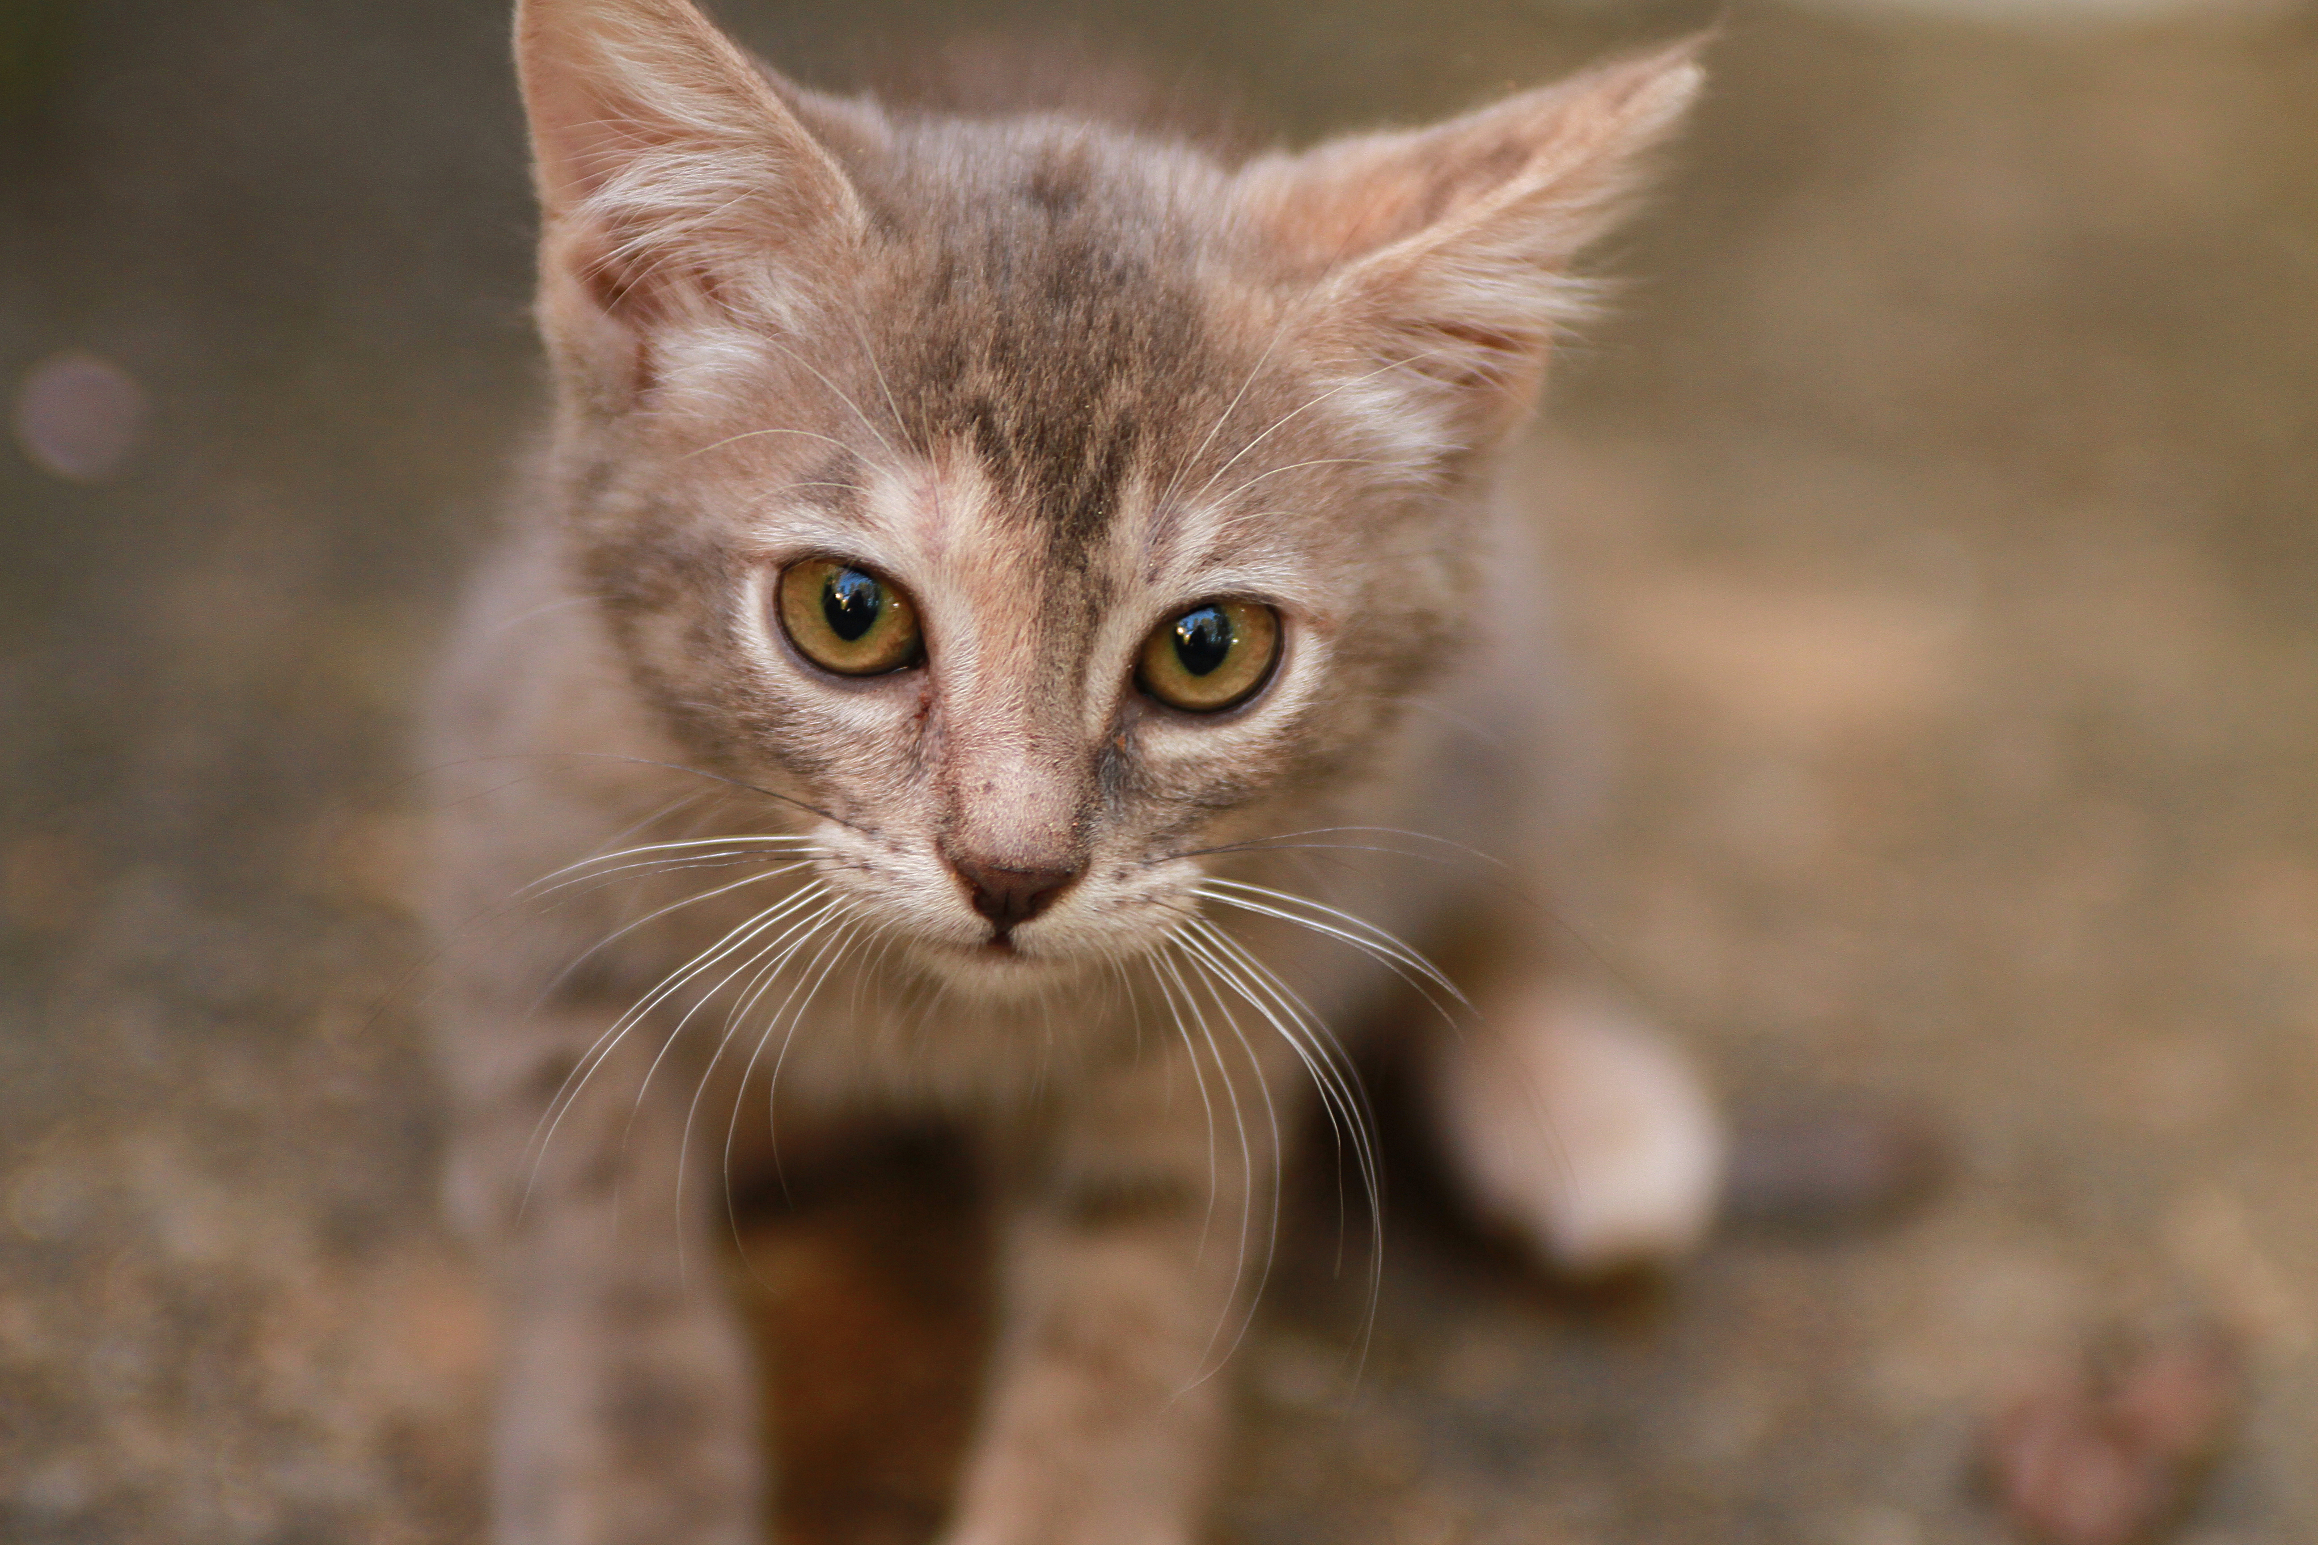

***This image is bold and italic:***

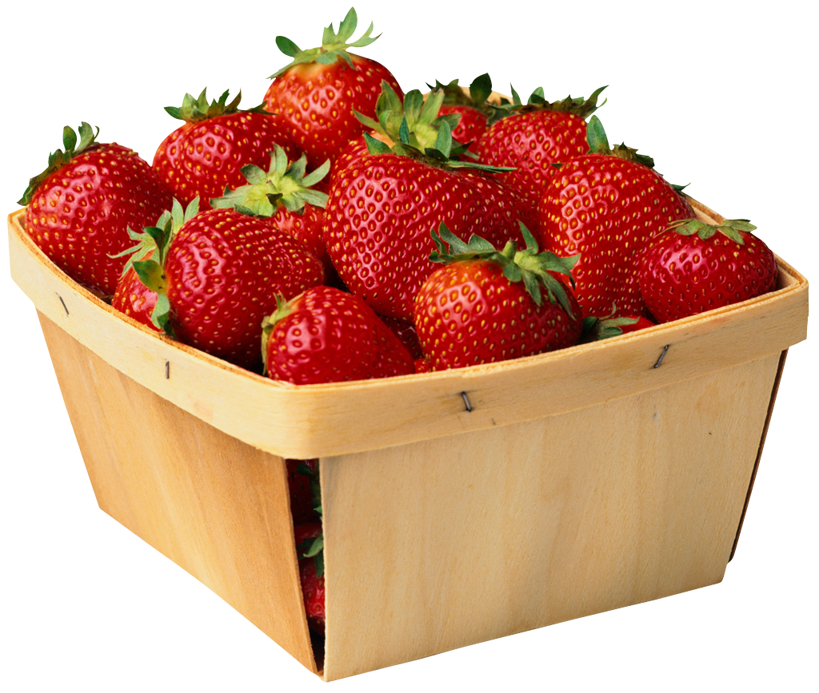 ***bold and italic***

**Word art!**

## Math

Some default formulas:

$$A=πr^{2}$$

$${\left(x+a\right)}^{n}=\sum_{k=0}^{n}{\left({n \atop k}\right)x^{k}a^{n-k}}$$

$${\left(1+x\right)}^{n}=1+\frac{nx}{1!}+\frac{n\left(n-1\right)x^{2}}{2!}+…$$

$$a^{2}+b^{2}=c^{2}$$

When ∠ABC = 90° and $∠ BCD=90°$, then $\overline{AB}∥\overline{CD}$. Now find point $(a,b,c)$ on your map, and see that $\left(P | Q\right)=(P|q⊂Q)$. Yeah, $0.9=.9≠000.000$.

Watch out for $whitespace and text in$ your equations. Even in $\frac{fractions and such}{or with other styling}$. Let’s try a $\frac{small}{fraction} and some other text in here.$

$start with some equation$ which is then followed by some other tekst.

$$\sin^{-1}{e^{-iωt \sqrt[a]{b}} 1/3}$$

$$\left\langle super | funky | triple\right\rangle$$

$$f\left(x\right)=\left\{\begin{aligned}-x, &x<0 \\ x, &x≥0\end{aligned}\right.$$

$$\frac{-b±\sqrt{b^{2}-4ac}}{2a}$$

$$\sum_{\begin{aligned}0≤ i ≤ m \\ 0<j<n \end{aligned}}{P\left(i,j\right)}$$

Lets try some lists with math:

$a+b=∞$

* And $e^{iπ}+1=0$, right?